**Project Phase-3  
Name: Soham Nandi**

**______________________________________________________________________________**

**Screenshots that you successfully can import and use libraries**

*Installing Python*

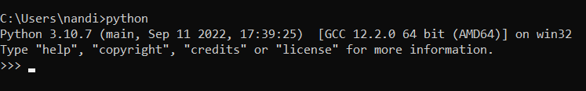

*Installing psycopg2*

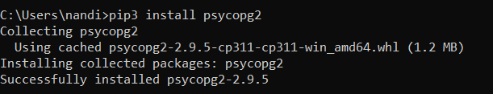

*Installing pandas*



It’s showing that ‘pandas’ is already installed.

**Screenshots that you successfully established your connection with Postgres**



**2 new questions**

1. Write a query in SQL to find the total number of goalless draws have there in the entire tournament.

ANS: SELECT COUNT(DISTINCT match_no   
 FROM match_details   
 WHERE win_loss = 'D'   
 AND goal_score = '0'

Output using Python:

No. of rows returned: 1

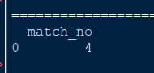

Output of same query in pgAdmin:

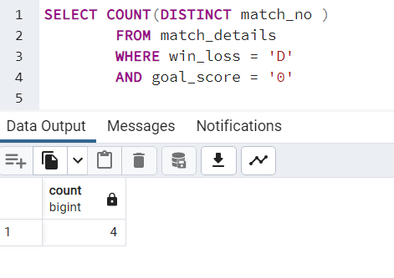



1. write a SQL query to find the highest audience match. Return match_no, play_stage, audience.

ANS: SELECT match_no, play_stage, audience   
 FROM match_mast   
 WHERE audience=(SELECT max(audience)   
 FROM match_mast);

Output using Python:

No. of rows returned: 1

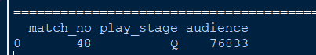

Output of same query in pgAdmin:

